Báo cáo thực nghiệm Linear Regression

Thông tin sinh viên:

* Tên:
* MSSV:
* Lớp:

1. **Kết quả thực nghiệm**

|  |  |  |  |  |  |  |  |
| --- | --- | --- | --- | --- | --- | --- | --- |
| **Stt** | **;r** | **init_b** | **init_m** | **iter** | **b** | **m** | **cost** |
| 1 | 0.001 | 20 | 0 | 10 | -21473.827  921223616 | -1093571.71  40260246 | 2981246147343924.5 |
| 2 | 1 | 0 | 10 | 20 | 1.4904414  897134555e+73 | 7.58313200  0168711e+74 | 7.583132000  168711e+74 |
| 3 | 0.1 | 0.1 | 2 | 2 | -4.956326  473886448 | -258.2933  45102149 | 168221067.73085958 |
| 4 | 0.01 | 0.001 | 0 | 100 | -2.1857957543  870683e+167 | -1.112098518  8162011e+169 | inf  /usr/local/lib/python3.7/dist-packages/ipykernel_launcher.py:9:  RuntimeWarning: overflow  encountered in double_scalars  if __name__ == '__main__': |
| 5 | 1 | 1 | 1 | 1 | 46.553418  184254234 | 2291.8639  125078203 | 13077678306.418434 |
| 6 | 0.11 | 10 | 0.5 | 1 | 18.4162935  61039495 | 429.56324  50807791 | 457255228.4065957 |
| 7 | 10 | 11115 | 3 | 1 | -212667.7994  7661987 | -10959186.94  8513538 | 2.994021882  2193555e+17 |
| 8 | 0.00001 | 0.0002 | 30 | 15 | -0.2997826  302419643 | 14.732427  779534902 | 437237.2534493645 |
| 9 | 10 | 20 | 10 | 1 | -8716.9672  81238143 | -444058.54  46647247 | 491570003225496.3 |
| 10 | 7 | 0.5 | 20 | 1 | -12696.544  901485011 | -646196.920  5175098 | 1040960090074570.2 |
| 11 | 10 | 25 | 0.2 | 11 | 7.294731188  077858e+49 | 3.711444554  296245e+51 | 3.433905897404813e+106 |
| 12 | 0.1 | 1000 | 10 | 10 | 5.1296740015  117596e+26 | 2.609897492  7741563e+28 | 1.698045550134423e+60 |
| 13 | 0.1 | 100 | 0 | 10 | 8.847871470  760575e+24 | 4.50165791  4542054e+26 | 5.0518147264775815e+56 |
| 14 | 100 | 100 | 100 | 100 | nan | nan | nan |
| 15 | 0.001 | 1000 | 100 | 10 | 2339033.6  97311682 | 118955617.1  0491347 | 3.527544300991483e+19 |
| 16 | 0.555 | 77 | 0 | 10 | 1.740818710  338854e+31 | 8.857011939  060352e+32 | 1.9555858936324e+69 |
| 17 | 0.12345 | 50 | 5 | 20 | 5.173812168  374247e+54 | 2.632354298  2156145e+56 | 1.7273928594077628e+116 |
| 18 | 77777 | 100 | 5 | 0 | 100 | 5 | 75396.95404435147 |

1. **Kết quả minh họa**

Lần 1 (lr=0.001, init_B=20, init_m=0, iter=10)

Lần 2 (lr=1, init_b=0, ini_m=10, iter=20)

Lần 3 (lr=0.1, init_b=0.1, ini_m=2, iter=2)

Lần 4 (lr=0.01, init_b=0.001, ini_m=0, iter=100)

Lần 5 (lr=1, init_b=1, ini_m=1, iter=1)

Lần 6 (lr=0.11, init_b=10, ini_m=0.5, iter=1)

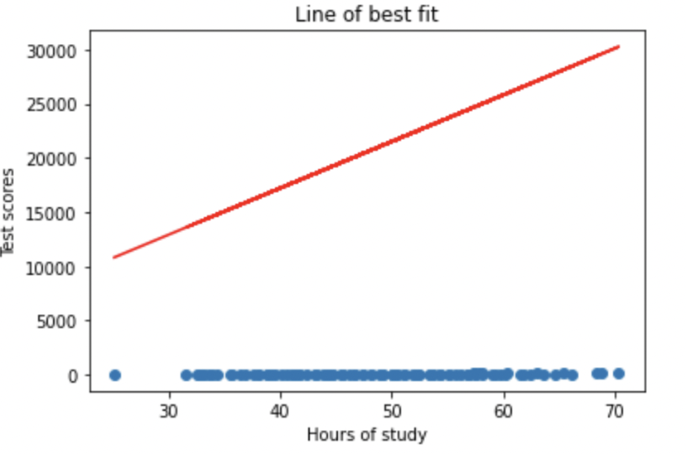

Lần 7 (lr=10, init_b=11115, ini_m=3, iter=1)

Lần 8 (lr=0.00001, init_b=0.0002, ini_m=30, iter=15)

Lần 9 (lr=10, init_b=20, ini_m=10, iter=1)

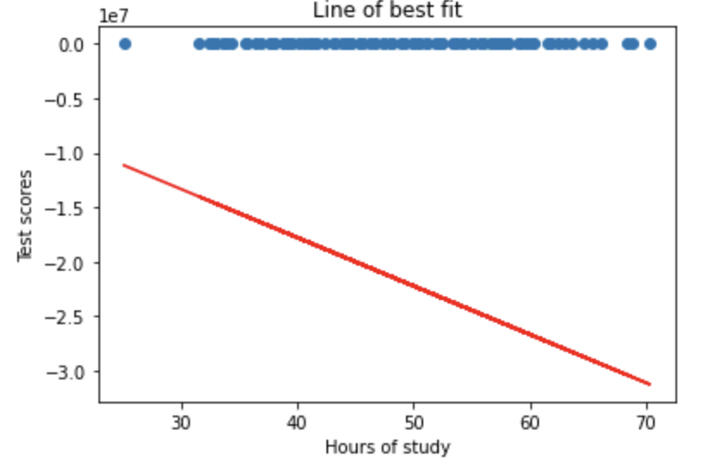

Lần 10 (lr=7, init_b=0.5, ini_m=20, iter=1)

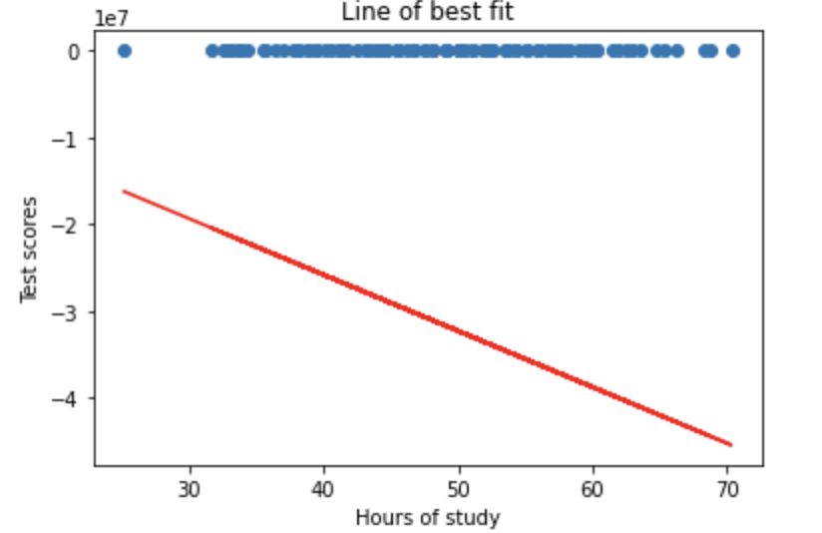

Lần 11 (lr=10, init_b=25, ini_m=0.2, iter=11)

Lần 12 (lr=0.1, init_b=1000, ini_m=10, iter=10)

Lần 13 (lr=0.1, init_b=100, ini_m=0, iter=10)

Lần 14 (lr=100, init_b=100, ini_m=100, iter=100)

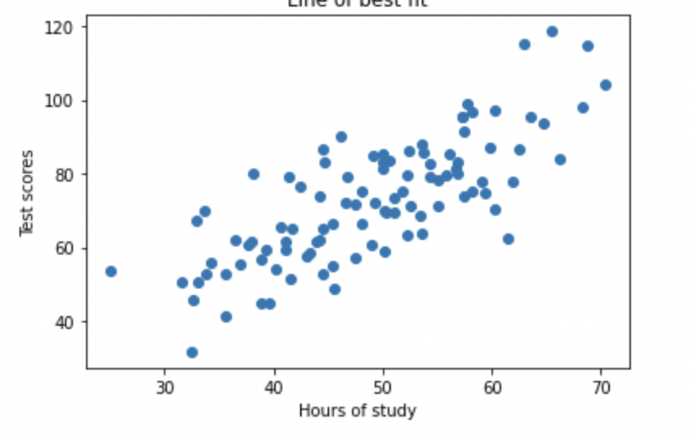

Lần 15 (lr=0.001, init_b=1000, ini_m=100, iter=10)

Lần 17 (lr=0.12345, init_b=50, ini_m=5, iter=20)

Lần 18 (lr=77777, init_b=100, ini_m=5, iter=0)

